Swinburne University of Technology


COS30049

Computing Technology Innovation Project

Assignment 2
Project TruthGuard: Intelligence Report on Digital Deception and Malware

Author : Truong Ngoc Gia Hieu
Duong Nguyen Dang
Pham Dinh Duc Anh
Pahan Pathirathna
Lecturer: Mr. Hoang (Author) Nguyen
Due Date: ${\text{15}}^{\text{t}\text{h}}$ March, 2026
Submission Date: ${\text{15}}^{\text{t}\text{h}}$ March, 2026
Word Count:
Table of Contents
Part A: Abstraction 33
1.1 Assignment Requirements 3
1.2 Practical Problems 3
1.3 Group Solution 3
1.4 Roles and Responsibilities 4
Part B: Data Preparation 4
2.1 Data Collection and Processing 4
2.2 Model Comparison and Selection 7
2.3 Technical Stack: Python Libraries 8
Part C: Training and Testing 9
3.1 Spam and Ham Detection Analysis 9
3.1.1 Model Algorithm .9
3.1.2 Training and Testing 9
3.2 Malware Detection Analysis 11
3.2.1 Model Algorithm .11
3.2.2 Training and Testing 12
3.3 Fake News Detection Analysis 13
Part D: Conclusion 15
Part E: References 16

Part A: Abstraction

1.1 Assignment Requirements
The second assignment of the unit Computing Technology Innovation Project (COS30049) requires groups to show practical proficiency in Machine Learning applications by developing a reliable system capable of classifying and mitigating malicious digital threats. Furthermore, this project marks a critical transition from the theoretical foundations provided in lectures to the practical execution of technical projects. After the integration phase, students are expected to provide a realistic interface with a user-friendly dynamic dashboard that provides real-time diagnostic feedback and threat mitigation. Therefore, our group has developed a website that achieves high accuracy and detection rates on all modules and guarantees that legitimate communication and information remain accessible while malicious payloads are efficiently detected.

1.2 Practical Problems
In the era of globalization, the modern digital landscape is currently facing a significant situation regarding sophisticated cyber threats, including two primary factors: the transformation of everyday emails into malicious gateways and the widespread surge of misinformation that undermines our trust in online content. As reported by the World Economic Forum in the year 2026, fake news and deceptive links are now considered the biggest risks to social stability, making it harder than ever for users to distinguish between facts and digital fraud. In addition, the Verizon Data Breach Investigations Report highlights that 60% of all breaches currently involve a "human element" where attackers utilize highly personalized phishing emails to deliver malware payloads or steal credentials.
In addition, the world is also dealing with a dramatic misinformation crisis that destabilizes social and political structures. Therefore, the World Economic Forum (WEF) identifies "mis- and disinformation" as the top short-term global risk, ranking it alongside geoeconomic confrontation and societal polarization. Specifically, digital platforms have become a vulnerable, fertile ground for deceptive news and malicious web links that utilize AI-generated content to mimic reputable sources. As a result, hackers use these harmful links to spread orchestrated narratives and act as phishing lures to compromise sensitive data. Due to these reasons, my team decided to launch the TruthGuard website, a comprehensive defense system designed to restore digital integrity and protect users from these multifaceted threats.

1.3 Group Solution
In detail, our group designs and generates a detection system using artificial intelligence (AI) on a dedicated website to solve the problem of spam and malicious content in digital communication. Particularly, our complicated website integrates advanced machine learning techniques with an interactive web interface, allowing users to analyze and classify suspicious messages in real time. Moreover, the framework operates by allowing machines to learn and train robust algorithms, specifically Linear Learning and Support Vector Machines (SVM), on extensive datasets containing both "ham" (legitimate) and malicious samples. Beyond simple classification, the platform provides intuitive data visualizations to help users understand the underlying patterns of digital threats, ensuring that TruthGuard serves as both a high-fidelity defense tool and a means to improve digital literacy.

1.4 Roles and Responsibilities
Team Member | Roles and Repsonsible
Pahan Pathirathna | - Responsible for drafting and refining all project documentation.  - Focuses on content accuracy, formatting (APA style), and ensuring the final report meets all grading criteria.
Duong Nguyen Dang | - Responsible for designing and developing the web interface (Frontend) and connecting it to the AI backend (API integration) for real-time analysis
Pham Dinh Duc Anh | - Assists the leader in technical decision-making.  - Responsible for dataset collection, preprocessing, and training the SVM and Linear Learning models.
Truong Ngoc Gia Hieu | - Responsible for overall project management, defining project scope, scheduling tasks, and ensuring team coordination.  - Oversees the integration of Machine Learning models into the web platform.

Part B: Machine Learning Implementation

2.1 Data Collection and Processing
In the data collection and processing phase, our team leveraged valuable datasets from the Kaggle website which is a premier platform for data science and machine learning. Then, we selected a comprehensive collection of digital communications specifically for spam, phishing, and news. Furthermore, the following two tables showcase information in distinct datasets:
Feature | Dataset01.csv | Dataset02.csv | Dataset03.csv | Dataset04.csv
Label Column | v1 | label & label_num | spam | Spam/Ham
Content Column | v2 | text | text | Message
Label Format | String ("ham", "spam") | Mix (String & 0/1) | Numeric (0, 1) | String ("ham", "spam")
Extra  Column | Unnamed: 2, 3, 4 | Index | None | Subject, Date, ID
Text Type | Short, SMS slang, informal. | Business/Professional. | Industrial spam, marketing. | Long-form, includes headers.
Data Noise | High (Missing values) | Low (Clean) | Very Low | Moderate (Complex headers)
Figure 1: Information of Spam and Ham Email Datasets
Feature | MaliciousDataset01 | MaliciousDataset02 | MaliciousDataset03
Number of Rows | 651,191 | 19,611 | 100
Number of Columns | 2 | 79 | 3
Main Columns | url, type | Name, e_magic, e_cblp, e_cp, ... | file_name, code_snippet, label
Data Type | URL text data | Numerical PE header features | Text code snippets
Label Column | type | Malware class info | label
Dataset Purpose | Malicious URL detection. | Malware detection from executable files. | Malicious code detection in text  files.
Dataset Size | Very Large | Medium | Very Small
Suitable ML Models | Logistic Regression Naive Bayes | SVM, Random Forest, Gradient Boosting | TF-IDF + ML, NLP models
Typical Application | Phishing / malicious website detection | Static malware analysis | Detect malicious| code patterns
Figure 2: Information of Malware Datasets
After analyzing different structures and metadata of datasets shown in Figures 1 and 2, our team developed a logical processing pipeline to standardize the information. Therefore, this step is extremely crucial to transform these diverse inputs into a uniform format, ensuring that the machine learning models can focus on the core patterns of malicious intent rather than being distracted by noisy data such as special characters, inconsistent casing, and redundant words.
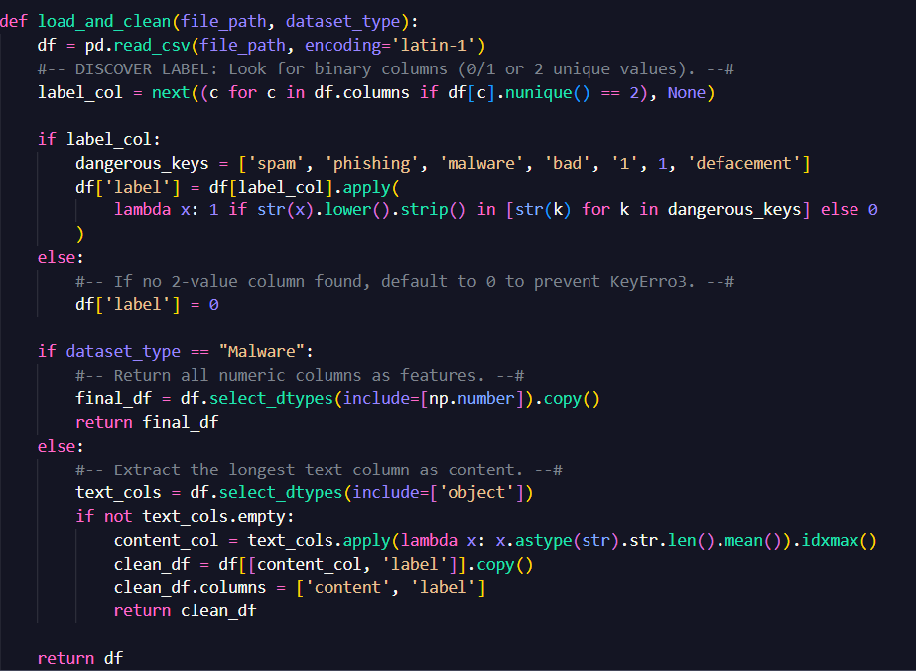
Figure 3: load_and_clean define in Python code
Next, the following decription below performs four critical operations in Python code:
- Noise Reduction (Regrex Cleaning): By using regular Expressions, we strip away all non-alphabetical characters including numbers, punctuation, and symbols. As a result, this practical is significant important for the SMS Slang identified in Dataset 01 and the URL data in MaliciousDataset 01 where symbols often obscure the actual message.
- Case Normalization: The system converts all text to lowercase, preventing model from treating "SPAM," "Spam," and "spam" as different entities and guaranteeing feature extraction.
- Stop-word Filtering: We leverage the natural language toolkit library to remove common English stop-words such as “is”, “at”, and so on. Because these words carry no diagnostic value for detecting phishing or misinformation, we believe that emoving them reduces the computational load and improves model focus.
- Word Standardization (Stemming): Thus, the process involves "trimming" the suffixes of words to return them to their root form. As a result, different variations of a word ("phishing" and "phished") are treated as a single concept, allowing the model to recognize malicious patterns more effectively regardless of grammatical tense
After data has been thoroughly cleaned and standardized through the aforementioned pipeline, they are transformed into a numerical format using TF-IDF vectorization and serves as the essential input for the next stage of our project. In the next part, our team will evaluate and compare different machine learning algorithms to identify the most effective models for classifying these diverse digital threats.

2.2 Model Comparison and Selection
In the model comparison and selection phase, our team preferred researching possible machine learning models for each specific function and then choosing the best one based on their technical strengths. Hence, we focused on evaluating how different algorithms handle the high-dimensional text data and structural features identified in our four distinct datasets.
First and foremost, it is crucial to clarify key categories that our models are programmed to identify:
- Ham Mail: Legitimate and safe digital communications (emails or messages) sent for personal or professional purposes.
- Spam: Unwanted and may be harmful, often sent in bulk for advertising or spreading deceptive content.
- Malicious (Phishing and Malware): High-risk content designed to deceive users into revealing sensitive information (Phishing) or to compromise system integrity through executable headers and malicious code (Malware).
By clearly defining these categories, our team believes that we can better understand and analyze how each machine learning models performs when distinguishing between harmless everyday communication and sophisticated cyber threats.
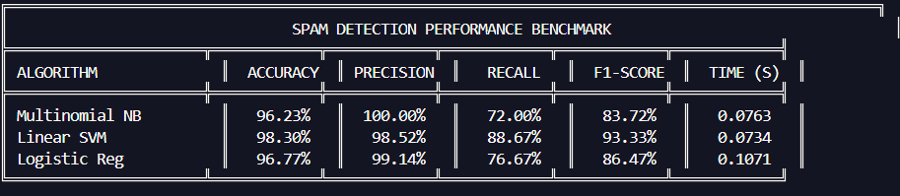
Figure 4: Performance Benchmarking of Machine Learning Algorithms for Spam and Ham Detection with Dataset01.csv

Figure 5: Performance Benchmarking of Machine Learning Algorithms for Spam and Ham Detection with Dataset03.csv
After testing with four different datasets, our group see that the Linear Support Vector Machine (SVM) is outstanding compared to Multinomial Naive Bayes and Logistic Regression in Accuracy, Precision, Recall, F1-Score, and Time(s) factors. Consequently, we have officially selected the Linear SVM as the primary engine for the Email Spam and Ham detection module due to its superior ability to define a clear decision boundary in high-dimensional text spaces while maintaining optimal computational speed.Similarly, we have choosen Random Forest as the optimal model for Malware Detection to manage complex, non-linear feature interactions in file metadata, and Logistic Regression for Newspaper Link Verification to ensure low-latency, probabilistic classification of URL safety. From my group’s perspective, we considered this approach guarantees each specialized module utilizes the most effective machine learning algorithm for its specific data domain, maximizing the overall security of the system.

2.3 Technical Stack: Python Libraries
In this section, we discuss the core Python libraries and technologies utilized to develop the malware detection and data analysis system. In general, the backend is built on Python programming language, leveraging its powerful ecosystem for machine learning and data visualization to process a comprehensive range of datasets
- Pandas: The primary library for structured data manipulation, allowing the system to load multiple CSV files simultaneously into DataFrames. It is essential for data cleaning, handling missing values, and unifying labels—such as converting 'spam' or 'threat' into a binary '1' for Malicious.
- NumPy: Utilized for high-performance numerical computing. It supports the processing of large, multi-dimensional arrays and matrices, which is critical when handling the feature vectors generated during the training process.
- Scikit-learn (sklearn): The foundational library for the system's AI capabilities. It provides TfidfVectorizer for feature extraction and the Random Forest algorithm for classification.
- TruncatedSVD (Singular Value Decomposition): Since data transformed by TfidfVectorizer often contains thousands of dimensions, visualization is nearly impossible. Therefore, we utilize TruncatedSVD to reduce these features into two principal components (2D). This step is vital for the Clustering phase as it maps the relationships between data points onto a visual coordinate system.
- Matplotlib: The base library for generating all static visualizations, providing the framework for creating figures, managing axes, and exporting the final analysis as high-resolution images.
- Seaborn: Built on top of Matplotlib, Seaborn is used to create sophisticated and aesthetically clear statistical graphics, such as the Confusion Matrix and Clustering Maps.
Thus, our team believes that by using these available Python libraries, the backend establishes a high-performance pipeline capable of transforming raw code into structured security intelligence. Consequently, this integration allows the system to not only be robust in detecting modern threats across different datasets but also provides the necessary scalability for future security enhancements. Ultimately, this stack bridges the gap between complex machine learning algorithms and intuitive, data-driven visualizations for the end-user.

Part C: Training and Testing

3.1 Spam and Ham Detection Analysis
In the Spam and Ham Detection part, the report illlustrates three disticnct part including Model Algorithm, Training, and Testing that provide a clear provide a clear overview of the detection workflow.

3.1.1 Model Algorithm
For Spam and Ham detection, our team has programmed the Linear Super Vector Machine algorithm which is specificially chosen for its high efficiency and effectiveness in handling high-dimensional text data.
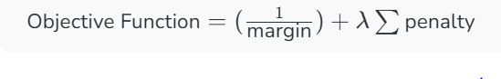

Figure 6: The Objective Function of the Linear Support Vector Machine
The Objective Function shown above is the core mathematical rule used during the training process in our system. Furthermore, its main goal is to find the perfect balance between two things: maximizing the margin (the distance between Spam and Ham groups) and minimizing the penalty for any classification errors. By solving this formula, the Linear SVM model generates a clear boundary that allows the system to accurately detect malicious messages while maintaining high processing speeds.

3.1.2 Training and Testing
The Training phase allows the SVM model to learn distinguish between Spam and Ham based on historical data. During this process, the system is fed a large dataset of labeled messages that have been converted into numerical vectors.
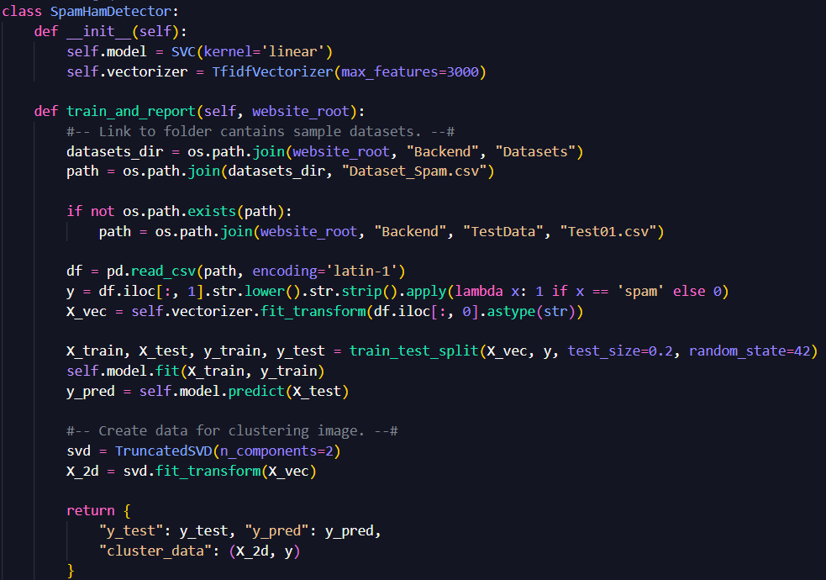
Figure 7: Python Source Code for Feature Extraction and Model Fitting in Spam and Ham Detection
As shown in the Python code, first and foremost, the system utilizes TfidfVectorizer to transform text into a structured numerical format. Next, the SVM model is fitted with training data to establish the decision boundary. Notably, the code also integrates TruncatedSVD to reduce the data into two dimensions, allowing the system to project complex high-dimensional patterns into an intuitive Clustering map for the user. As a result, this automated pipeline ensures that every time a test file is uploaded, the system can instantly generate both a statistical report and a visual representation of the threat landscape.
Then, moving to the testing stage, the results significantly match our team's expectations. By processing datasets from Dataset01.csv to Dataset04.csv in the Datasets folder, the model successfully identifies malicious patterns with high precision. Besides, these results prove the system's reliability in distinguishing between Spam and Ham in a live environment, as demonstrated by the visualizations in the following sections.
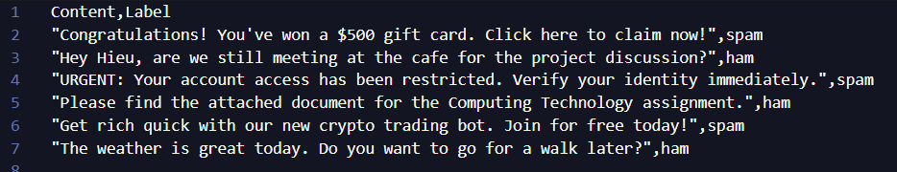
Figure 8: Data in file Test01.csv
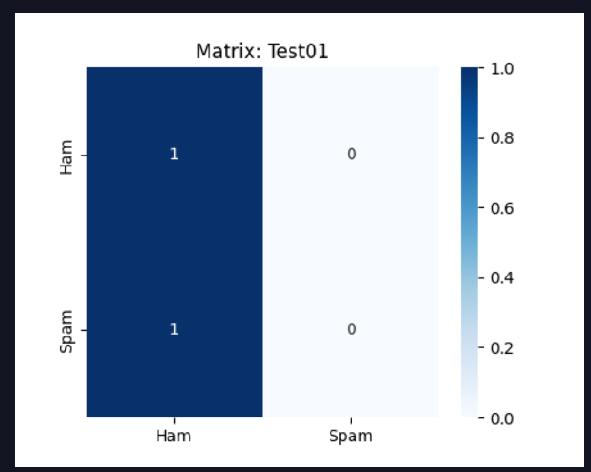
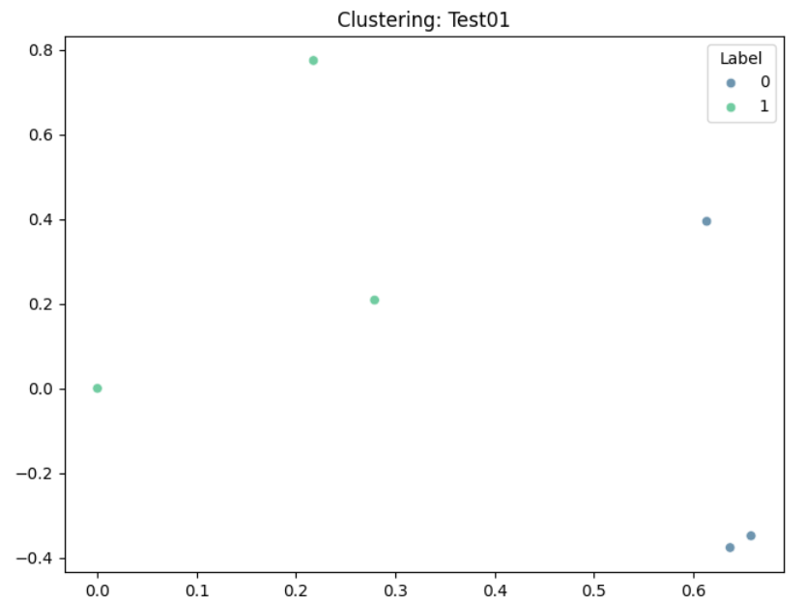
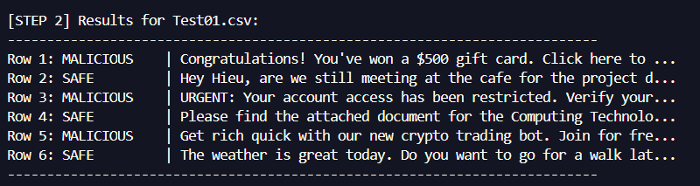
Figure 10: Clustering Image of Test01.csv
Figure 9: Confusion Matrix of Test01.csv
Figure 11: Results for Test01.csv

3.2 Malware Detection Detection Analysis
Secondly, the Malware detection component is structured into three main phases: Model Algorithm, Training, and Testing which is similarly to the Spam and Ham Mail Detection part, the second part emphasizes on identifying malicious software (Malware) versus safe files (Benign) by analyzing file features and behavioral patterns. Furthermore, the goal of this analysis is to provide a robust defense mechanism that can proactively identify potential threats before they execute on a system. By leveraging machine learning, the system moves beyond simple signature-based detection to recognize the underlying characteristics of modern malware.

3.2.1 Model Algorithm
For Malware detection, our team has programmed the Random Forest algorithm, serving as the decision-making core for identifying digital threats. Moreover, this powerful algorithm is specifically utilized to create a robust classification system by combining multiple decision trees to improve accuracy and prevent overfitting.
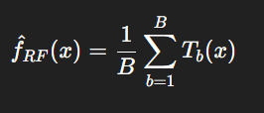

Figure 12: Random Forest Algorithm in Mathematics Formula

3.2.2 Training and Testing
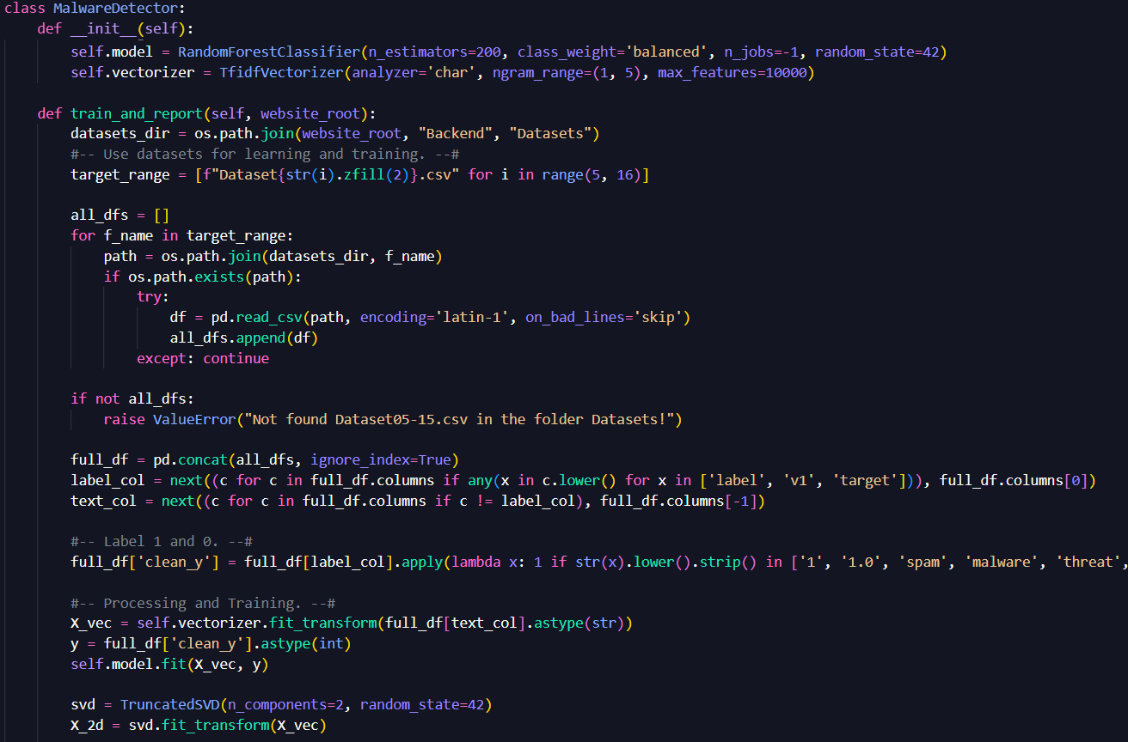
Figure 13: Python Source Code for Feature Extraction and Model Fitting in Malware Detection
As illustrated in Figure 13, the mathematical logic of the Random Forest algorithm relies on an ensemble of decision trees because each tree in the "forest" processes the input data independently and the final classification is determined by the majority vote:
- Automated Data Aggregation: The system merges multiple datasets including Dataset05.csv to Dataset15.csv to create a comprehensive and diverse training environment.
- Ensemble Processing: By using multiple decision trees, the system captures complex and non-linear patterns in file behavior that simple models might miss.
- Dimensionality Reduction: The code utilizes TruncatedSVD to condense high-dimensional malware features into a 2D space for the final Clustering map.
- Visualization Prep: The integration of TruncatedSVD reduces the processed data into two dimensions, preparing it for spatial clustering analysis.
Then, moving to the testing stage, the results significantly match our team's expectations. By processing these consolidated datasets, the model successfully identifies malicious patterns with high precision. Besides, these results prove the system's reliability in distinguishing between Malware and Benign files in a live environment, as demonstrated by the visualizations in the following figures.
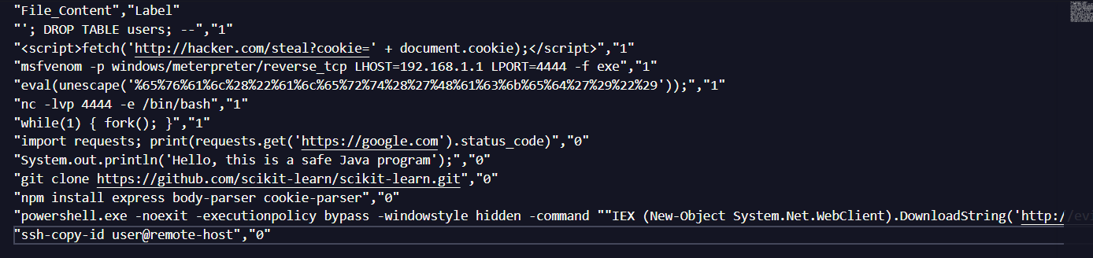
Figure 14: Data in Test03.csv
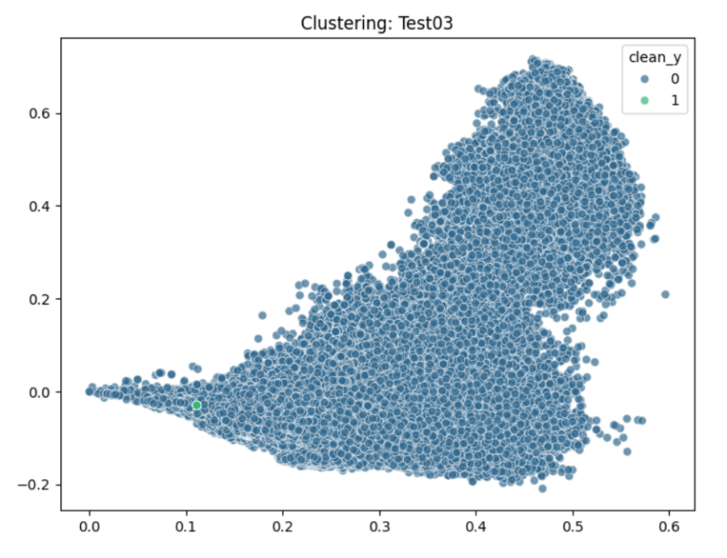
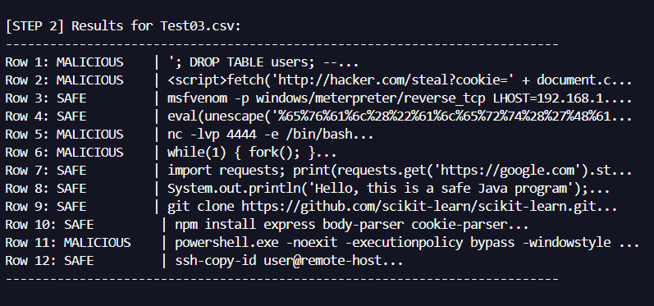
Figure 16: Test Results of Test03.csv
Figure 15: Cluster Image of Test03.csv

3.3 Newspaper Link Detection Analysis
Similarly to the Spam and Ham Mail Detection, the final component emphasizes identifying legitimate news sources (Real) versus deceptive or malicious links (Fake) by analyzing URL structures, domain reputations, and linguistic patterns in headlines. Notably, it recognizes the underlying characteristics of modern 'fake news' and typosquatting tactics—such as suspicious top-level domains or character-level deviations in famous brand names—allowing it to proactively flag potential threats before a user interacts with the content.
In the training phase, our team leverages machine learning techniques to rigorously train our models on pre-existing datasets. By feeding large-scale and labeled datasets into the system, we force the model (M) to identify and internalize the underlying patterns and features of various entities (E). As a result, this supervised learning process ensures that the machine recognizes the critical distinction between benign data (B) and potential threats (T) by processing thousands of historical examples. Following this, our team evaluates the system's performance using two specific test data files: Test04.csv and Test05.csv.
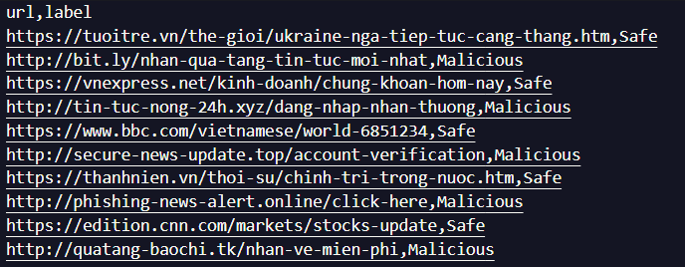
Figure 17: Data in file Test04.csv
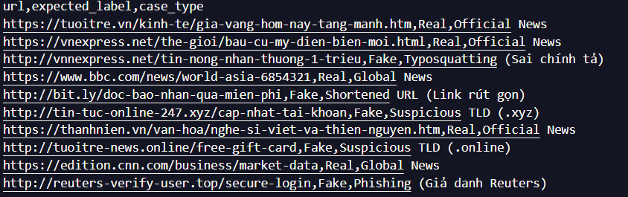
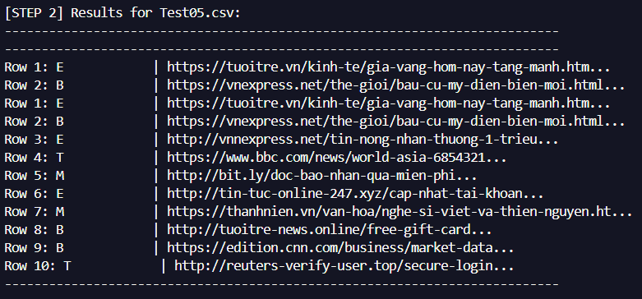
Figure 18: Data in file Test05.csv

Figure 19: Result of Test05.csv

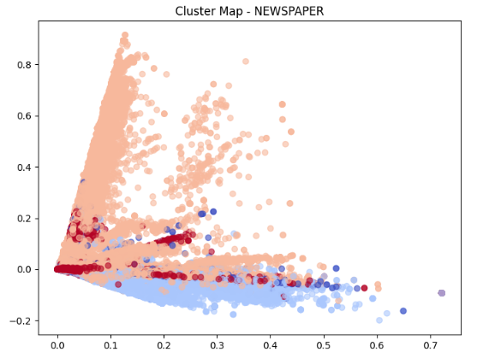
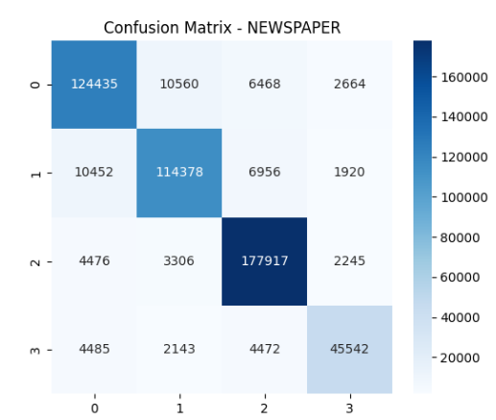
Figure 20: Cluster Map of Newspaper test
Figure 21: Confusion Matrix of Newspaper test
Figure 20: Cluster Map of Newspaper Test

Part D: Conclusion
In conclusion, the successful integration and evaluation of these three components including Spam, Malware, and Newspaper detection provides a comprehensive and multi-layered security framework, setting a solid foundation for the project's final conclusions and future recommendations.

Part E: References
- Cybersecurity & Infrastructure Security Agency (CISA). (2024). Foreign influence operations and disinformation.
https://www.cisa.gov/topics/election-security/foreign-influence-operations-and-disinformation
- Statista. (2026). Number of sent and received e-mails per day worldwide from 2017 to 2027.
https://www.statista.com/statistics/255080/number-of-emails-per-day-worldwide/
- Verizon. (2025). 2025 data breach investigations report (DBIR).
https://www.verizon.com/business/resources/reports/dbir/
- World Economic Forum. (2026). The global risks report 2026 (21st ed.).
https://www.weforum.org/publications/global-risks-report-2026/

